4 Assignment Day 8 | 9th December 2020

**Assignment 0**

1. Create a simple shell script to tell the user about their session – they

need to know:

● What their username is

● What the current date is

● What the time is

● What their current working directory is

● How many files they have in that directory

● What is the biggest file in their current directory

**Assignment 1**

Create a directory with a few test files in it (the files can be empty). Now write a script that for

every file in that directory you rename it to have an extension of today's date in YYYYMMDD

format.

**Assignment 2**

Write a script that takes a number as an input and reverses it out to the user. For example, if the

original number is 74985, the output should be 58947.

Linux Administration Essentials| December 2020

**Assignment 3**

Write a script to validate how secure someone's password is. Things you would care about:

● Length should be 8 or more characters

● The password should contain numbers and letters

● There should be both uppercase and lowercase letters

**Assignment 0**

**Script**

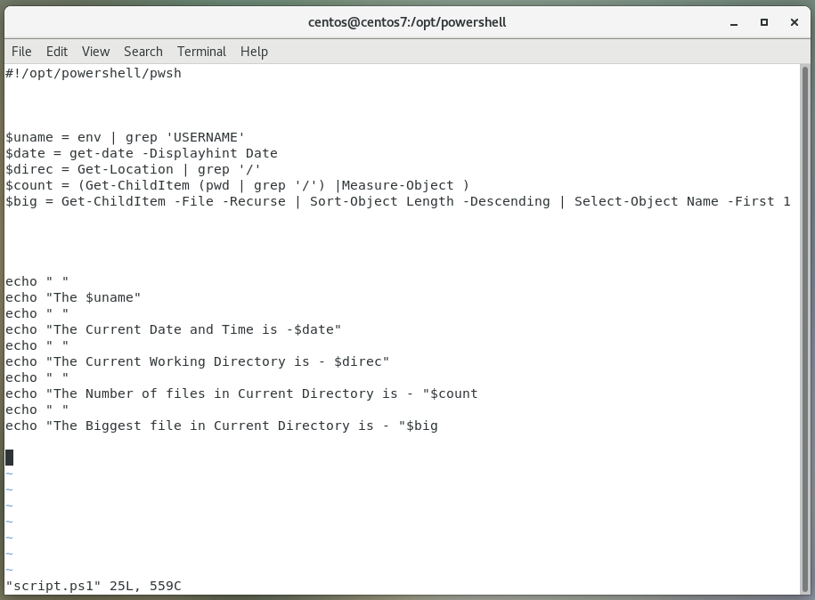

**Running script**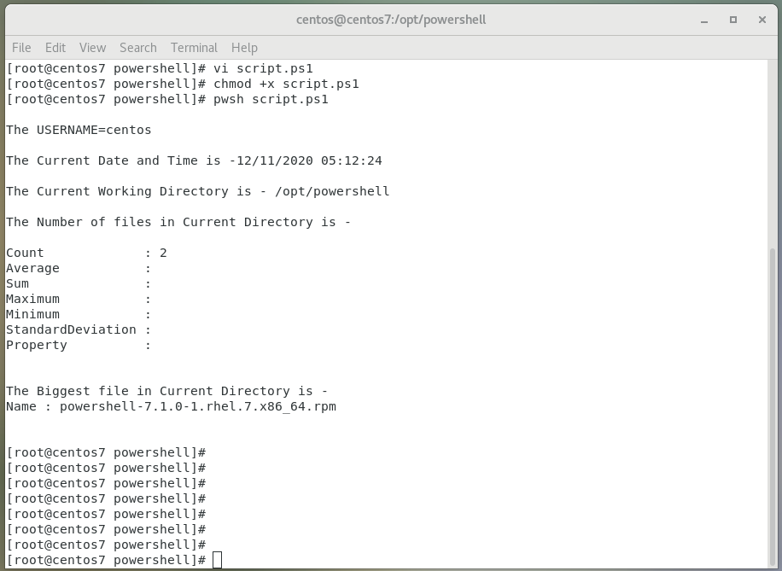

**Assignment 1**

**Running Commands**

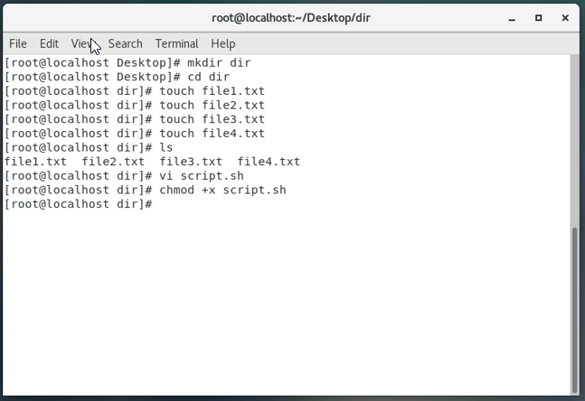

**Script**

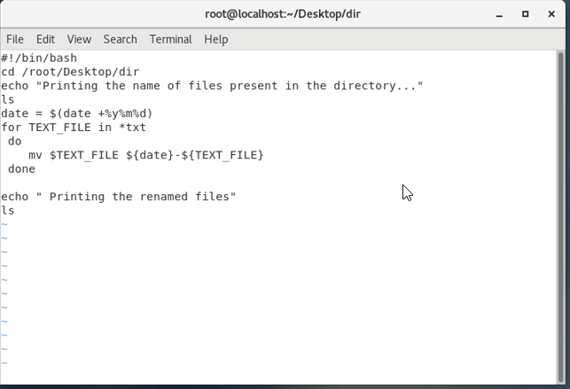

**Running Commands**

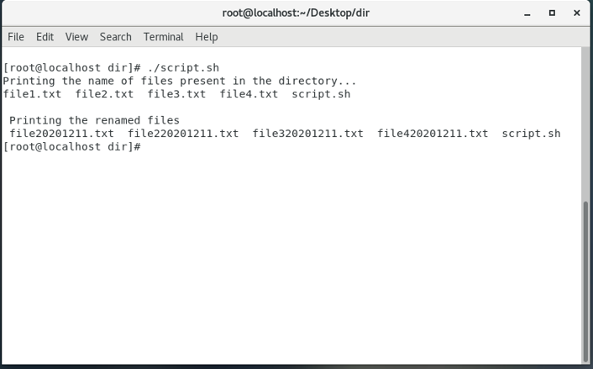

**Assignment 2**

**Script**

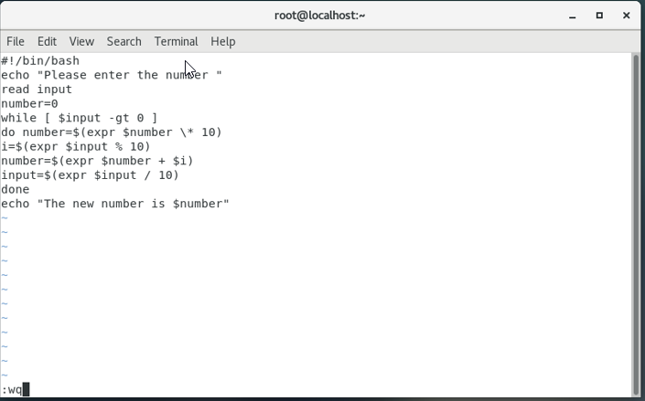

**Running Commands**

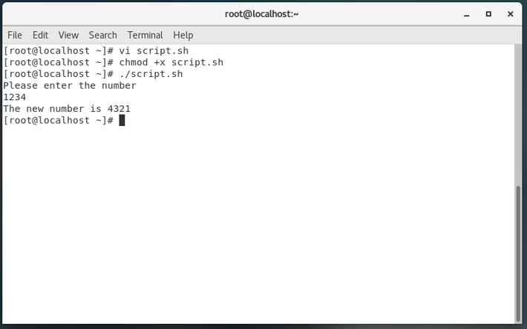

**Assignment 3**

**Script**

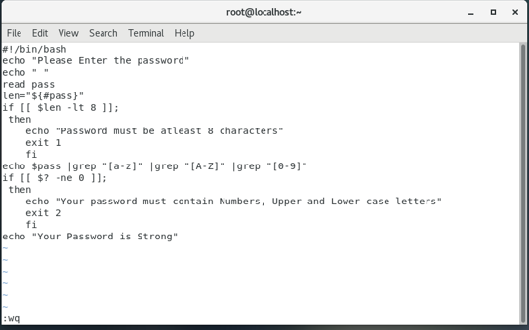

**Running Commands**

